**Ideation Phase**

**Define the Problem Statements**

|  |  |
| --- | --- |
| Date | 06 OCTOBER 2022 |
| Team ID | PNT2022TMID36196 |
| Project Name | FERTILIZERS RECOMMENDATION FOR DISEASE PREDICTION |
| Maximum Marks | 2 Marks |

**Customer Problem Statements :**

**Problem statement 1:**

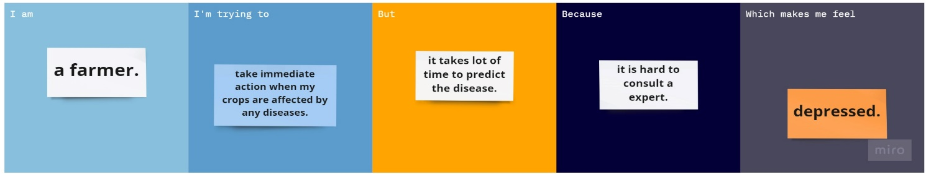

**Problem statement 2:**



|  |  |  |  |  |  |
| --- | --- | --- | --- | --- | --- |
| **Problem Statement (PS)** | **I am (Customer)** | **I’m trying to** | **But** | **Because** | **Which makes me feel** |
| PS-1 | A farmer. | Take immediate action when my crops are affected by any disease. | It takes lot of time to predict the disease. | It is hard to consult a expert. | Depressed. |
| PS-2 | A farmer. | Protect my crops from getting affected by diseases. | It takes lot of time to predict the disease. | Lack of knowledge on diseases and there pesticides. | Regretful. |